JH6. FRANK HURLEY REAL PHOTO SERIES [n.l. 1927]

Ph Frank Hurley
F Title in Roman Caps.

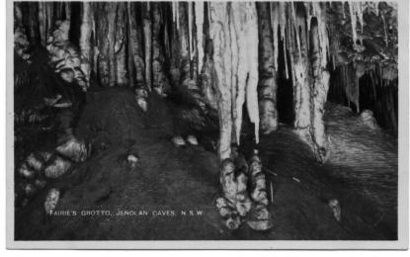
JH6.1 Crystal Cities, Jenolan Caves, N.S.W. H (s.n.a. JH2.5) [pm.22 Jan.1930] K-D
JH6.2 Exhibition Cave, Jenolan Caves, N.S.W. H [ms.1927] K-D
JH6.3 Grand Stalactites, Jenolan Caves, N.S.W. V K-D
Grand Stalactites, Jenolan Caves, N.S.W. V K-F
JH6.4 Gem of the South, Jenolan Caves, N.S.W. V K-B
Gem of the South, Jenolan Caves, N.S.W. V K-D
JH6.5 Giant Columns, Jenolan Caves, N.S.W. V K-B
JH6.6 Fairie's Grotto, Jenolan Caves, N.S.W. H K-F
JH6.7 The Mystery, Jenolan Caves, N.S.W. H K-B
JH6.8 Angel's Wing, Jenolan Caves, N.S.W. V K-F
JH6.9 Gem of the West, Jenolan Caves, N.S.W. H K-F
Gem of the West, Jenolan Caves, N.S.W. H [pm.3 Jan.1931]
JH6.10 Commonwealth Pillar, Jenolan Caves, N.S.W.V K-D
Commonwealth Pillar, Jenolan Caves, N.S.W.V [pm. 8 June 1928]
JH6.11 Crystal Palace Jenolan Caves, N.S.W. V K-D
JH6.12 Oberon Grotto, Jenolan Caves, N.S.W. V K-D
JH6.13 Mafeking Cave, Jenolan Caves, N.S.W. V K-B
Mafeking Cave, Jenolan Caves, N.S.W. V K-D
JH6.14 The Minaret, Jenolan Caves N.S.W. K-D
JH6.15 Grand Column, Jenolan Caves, N.S.W. V K-B

